## **2.4 Requirement Analysis**

It is the way of determine the needs of users for the new or modified system so it can satisfy the overall need.

### **2.4.1 Functional Requirement**

Functional requirement are those requirement which are related to systems technical functionality, hard-software for operating as per the system user needs. It helps the users in performing their task easily up to the business requirement.

Functional Requirement of my project is presented below in tabular form including its dependencies and rational.

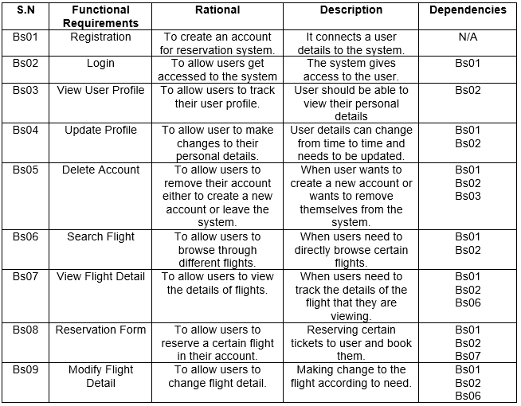

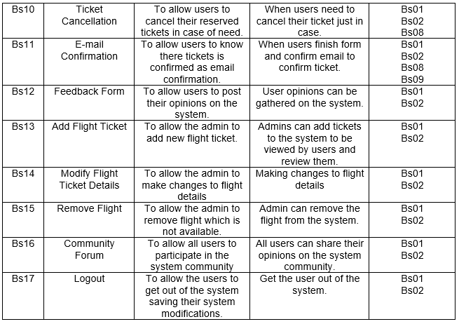

### **2.4.2 Non-Functional Requirement**

Non-Functional requirement are those requirement that specifies criteria which can be used for judging the system’s operation in particular conditions. It is also called “quality attributes” of the system. It determines particular conditions rather than some specific behaviors.

Non-Functional Requirement of my project is presented below in tabular form.

